Global Skills

**External Email : Be cautious while opening any links or attachments.**



GSI Student Experience using the Global Skills Initiative Portal hosted by Learn on Demand Systems

Lab Key

**E5B799FB0C704C07**

**Please go through the below instructions/steps to redeem the Lab Key.**

Lab key needs to be redeemed immediately as it has a limited validity. **Participants need to redeem the lab key with Corporate Account or Microsoft Account (Outlook, Live ID) during the session or before the session ends, Post session participant will not be able to redeem the lab key.** Once redeemed, the lab is accessible for 180 days.

**Please note that you can attempt/launch each lab 10 times. Please use it judiciously. Do not launch the labs unless the trainer has asked you to do so as you may lose out on attempts.**

Students will use an HTML5-compliant browser and navigate to <https://gsi.learnondemand.net/Class/690182> where they will be presented with the Global Skills Initiative Portal hosted by Learn on Demand Systems sign-in page where they will click **Sign In**.

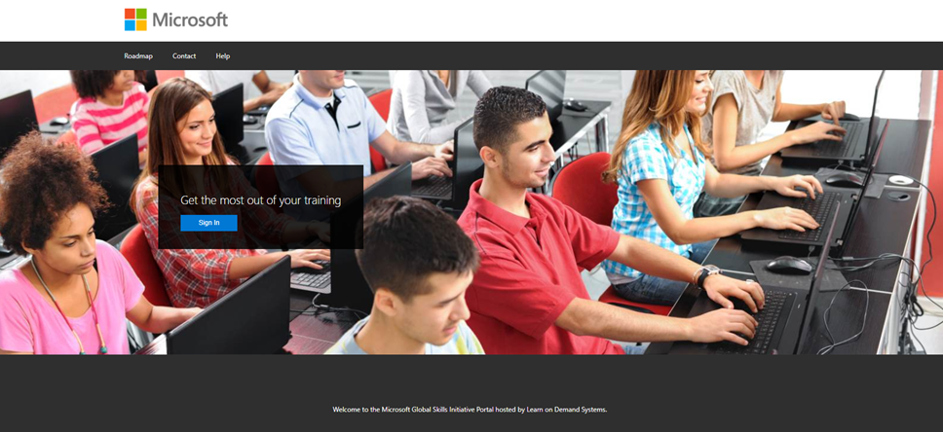

The student will then be required to select from the sign in options.

Most students should have a Microsoft Account (MSA) that they can use to access the training. They will select the **Microsoft Account** Option.

If they have an MS AAD account, they can select the **Corporate Account** option and enter their AAD credentials.

Once signed in they will be taken to the “Current Training” page.  This is where the Classes that they are currently enrolled in are listed.

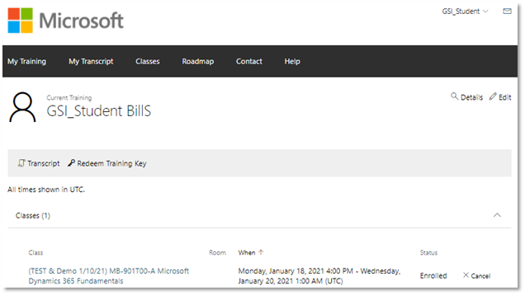

To be enrolled in a Class, Students redeem the Event Training Key provided by their Class Instructor.  To do this, select the **Redeem Training Key** link on the “Current Training” page.

Students will then enter the event training key provided to them by the instructor and click on the **Redeem Training Key** button.

The student will be taken to the Class page where they can see the list of labs along with any additional content for the course (if available). These materials can be videos, slide decks, surveys etc.

Students will see an indicator that they need to agree and accept the Microsoft EULA. They will not be able to launch labs until they accept this EULA. To accept they must click on “View Agreement”

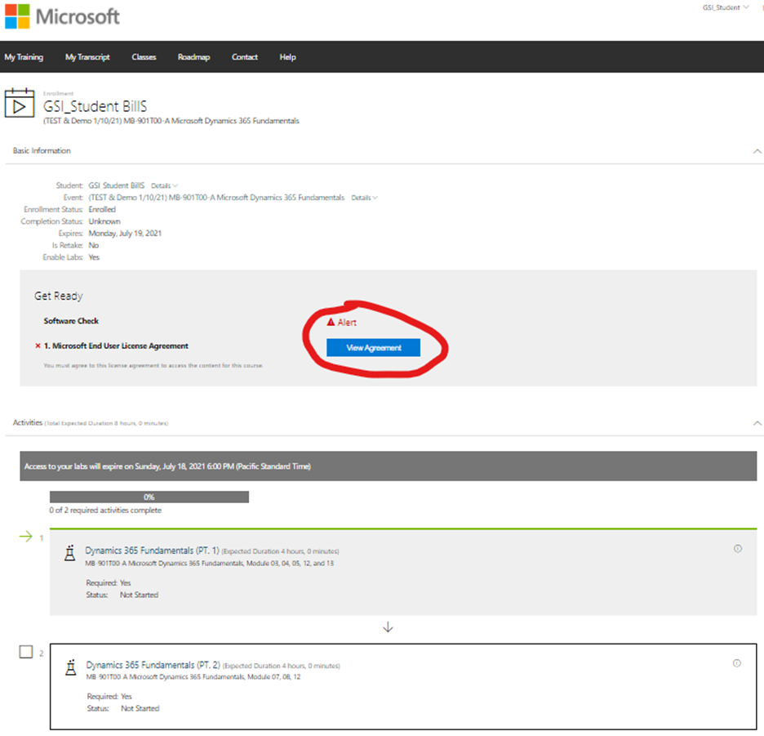

After reviewing the Microsoft EULA, click the “Agree” button.

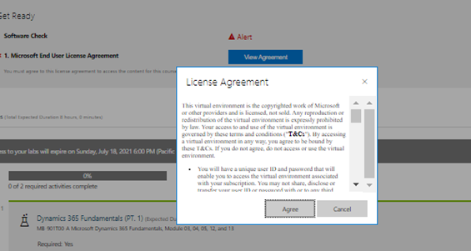

After they agree to the EULA, the students will see the “Launch” buttons will appear next to the labs. The student clicks on “Launch” for the desired lab and then accesses the lab interface for that lab.

When the student returns for subsequent training days for the class, they will sign in with the same method and account as they did for the beginning of the class. They will be taken to the “Current Training” page and from here they will see the class in the list under “Classes”. They will click on the link and be taken directly to the class page again, which allows them to resume the classes activities.

They can also see older classes they have taken, and if the post-event access window is still open for one of those classes, they can select that older class on their list of “Classes” to access the labs from that list.

|  |  |
| --- | --- |
| Thanks & Regards,    [for Synergetics Information Technology Services India Pvt. Ltd.](http://www.synergetics-india.com/)    Yash Sheth | Intern. Delivery Executive     +91 8355846917 |  |
|  |